**Macintosh HD:Users:silvia:Desktop:UiBlogo_Eng_gray_h.pdf**

****

**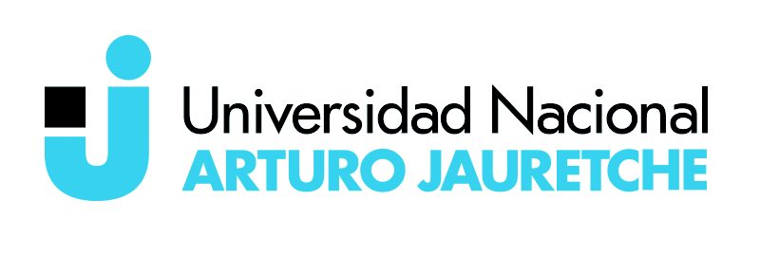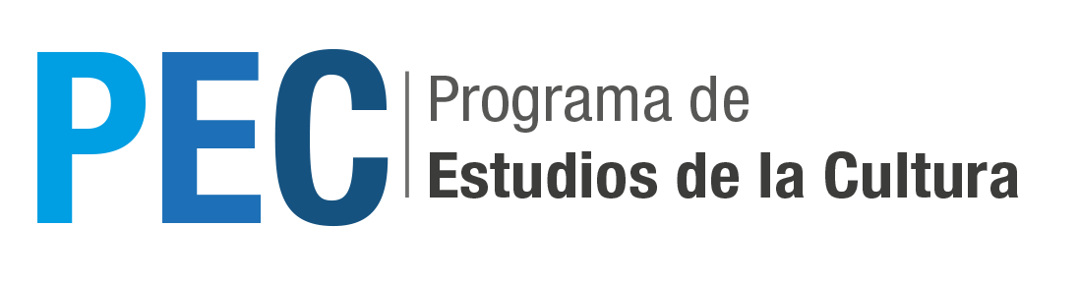**

**Health, Education and Water- UN Sustainable Development Goals:**

**Perspectives from Argentina, Norway and South Africa**

**UiB Global, IDEAS-UNSAM, UNAJ, Clea, PEC**

**NOVEMBER 9-10, 2017**

**Campus Miguelete - San Martín, Provincia de Buenos Aires**

**Edificio Volta, Ciudad Autónoma de Buenos Aires**

ORGANIZING COMMITTEE:

**UNSAM: Silvia Hirsch, Mercedes Biocca, María Florencia Blanco Esmoris**

**UNAJ: Christian de Ronde, Emilce Cuda**

**UiB Global: Hans Geir Aasmundsen**

**November 9**

Edificio de Ciencias Sociales, Universidad Nacional de San Martín, Campus Miguelete

10:00 Opening remarks: Hans Geir Aadsmundsen ( Bergen University)

10:30-12:30 Panel 1

**Panel 1**

**HEALTH Moderator: María Florencia Blanco Esmoris**

1. Silvia Hirsch (IDAES-UNSAM) “Is intercultural health possible in contexts of cultural friction and inequality? Mediations and obstacles in the access to health among indigenous peoples of northwest Argentina”
2. Susana Margulies (UBA) “Living with disease in the long duration in the metropolitan area of Buenos aires. Vulnerability from the perspective of  therapeutic itineraries
3. Hans Geir Aadsmundsen (Bergen University) “Pentecostalism and Health”

Lunch Break

**Panel 2**

**WATER Moderador: Hans Geir Aadsmundsen**

1. Constanza Riera (UBA-CONICET) “Lawless situations in the supply of groundwater irrigation in the north of Buenos Aires: Fear and moral sanctions among local populations' access to water”
2. Melina Tobias (UBA-CONICET) “Challenges and conflicts in the access to water and sanitation services in the Metropolitan Area of Buenos Aires”
3. Tore W. Saetersdal (University of Bergen at UiB Global/Center for International Health) “Water and the SDG's - an example from the Nile Basin"

Coffee break

**Panel 3**

**EDUCATION Moderator: Silvia Hirsch**

1. Jennifer Guevara (UNSAM) “Social Inclusion and Equity in Higher Education: The case of the teaching improvement program at Universidad Nacional de San Martin”
2. Natalia Ojeda, Andrea Lombraña, Monica Montero (UNSAM) “Inclusion in Higher Education among Penitentiary Inmates, in contexts of environmental and social inequality: The Cusam educational project”
3. Christian de Ronde (UNAJ, CONICET, UBA): "Politics in technological education"

**November 10**

Edificio Volta, Ciudad Autónoma de Buenos Aires

10:00-12:30

**Panel 4**

**GLOBAL CHALLENGES Moderador: Christian de Ronde**

* + - 1. Mariana Gainza (IIGG, UBA, CONICET): "The challenges of critics facing contemporary forms of subjection"
      2. Emilce Cuda (UNAJ): "Laudato Si: political theology criticizes the technocratic paradigm"

Discussion and further projects: Tore W. Saetersdal and Hans Geir Aadsmundsen